***How Our Business Works***

*D1 Explain how an organisation could improve the quality of its business information*

***Introduction***

I am going to be introducing how my business works. They’re functional departments in each organisation such as; marketing, finance, human resources, council and government. These are the main ones. I will be explaining the good characteristics of information set in each functional area. The manager will access the success of the business and I will ensure this is on-going by keeping customers available by quality is important than quantity. After, I will explain why software, hardware and training people are needed in each functional area;

* **Human Resources**
* **Marketing**
* **Finance**

Human Resources- Human resources role is to manage all the information for the employees, customers and employers. They ensure the working environment is safe and eligible to work. They recruit new candidates for the job, if there are any vacancies and provide training for the candidates. Also, they can make people redundant, if costs are too high. They raise alertness of workplace legislation. This all links to the functional areas stated above; *finance, government, marketing*. Finance links to HR, because HR needs to information of how much wages/salaries they get and finance needs the details of the employees. Also it links to marketing, because if my business is being promoted. They would need information where to contact me if there is any vacancy. HR links to government, because taking off taxes the employee’s salaries; they would need the employee’s details of how much they are getting paid, name, and address. Fit for purpose- Is the information given, useful in the long-term? This can tell us that if something is prepared beforehand, has it become useful. Some people can set objectives and if they follow them, they will achieve it. For example, a business plan is prepared for the business beforehand and there are specific set objectives to follow, but something goes wrong and they don’t follow it. They were no point of doing the business plan if you are not going to follow it. Accessible means if it is available for the target audience that the company has set. For example, if a company decides to sell suits for a company and markets only online. They would be a specific target audience for the people only who have online access. So they should figure another way, leafleting for example, that can be accessible. If they the information that they are trying to access is not accessible then they would potentially be losing customers.

[](http://www.google.co.uk/url?sa=i&rct=j&q=&esrc=s&frm=1&source=images&cd=&cad=rja&docid=h7DESROju_LqqM&tbnid=dJOCCM2SGnIgeM:&ved=0CAUQjRw&url=http://www.james-greenwood.com/2009/08/07/first-look-word-2010/&ei=kPRgUoXOFIa2hQfay4HICQ&bvm=bv.54934254,d.ZGU&psig=AFQjCNHY3_uEOTNUnXoRSKzhY-2tyCgIyg&ust=1382172172890701)[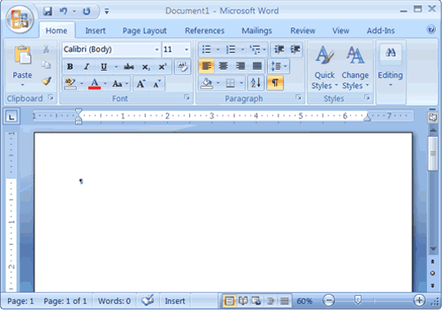](http://www.google.co.uk/url?sa=i&rct=j&q=&esrc=s&frm=1&source=images&cd=&cad=rja&docid=8mAX3ZC53qeqoM&tbnid=01_vtza22rjR5M:&ved=0CAUQjRw&url=http://www.baycongroup.com/word2007/01_word2007.html&ei=a_RgUpveCcSmhAeI9YDgAw&bvm=bv.54934254,d.ZGU&psig=AFQjCNFb2HCAFTVuc5rGLPfgRoSv0eLaRw&ust=1382172137830940)Specific softwares are needed in a business for each functional area. Especially for human resources they would need the whole of Microsoft; Access, Outlook, Powerpoint, Publisher, Word. Word is needed, because they would need to transfer data by either keeping all employee’s information or they can write a letter to other people. Outlook is needed, because they would need to email each other for documents to be sent to other employees or external communication would be needed such as; recruiting a new candidate for a new vacancy. Publisher would be needed, because they would need to produce advertisement for vacancies. These programmes would be strongly recommended to be updated as they would produce faster and efficient workers. They cost quite an extensive amount, but the difference is enormous. They would need anti-viruses for each computer to protect their data; same as all computers in the organisation, they would need to have antivirus on there computer. They would need to be updated as they can be new ways to protect their data. This is important as it would be aware of any viruses and any potential viruses. As you can see the difference below, 2007 word to 2010 word.

Hardware is things you can physically touch. These can be easily be broken. In any organisation, they would need computers. Computers can come in different types such as: touchscreen computers, laptops, untouchable computers. This is important to choose which type of computer is correct for each functional area. For example, if an employee accidently breaks his/her arm and he/she would need to be able to use a computer. Therefore, if have a touchscreen computer it would be useful whereas if the computer is not touchscreen then they would be an issue. Computers are needed in any organisation for computer-based work to be completed and stored. This is necessary, because if there wasn’t any computers around, they would have to complete the work hand-based which is longer and may get lost. As this could improve the quality of its business information by storing all the data into the computer. It will be secure and safe. USB is strongly recommended in a business, because it could improve how the flow of the information is transmitted. For example, if they lose their work they have another copy on their USB. This is important to improve quality of the business, because it gives another chance to get their information. It is recommended to have a faster processor such as; Intel I7. This is much faster than other processors whilst having a lot of data stored in the computer. However, they could start as a basic Intel computer, but if these cause enormous amount of issues, they could be replaced by a new processor. Remembering in mind that new processors and computers cost a lot.

Training people needs to be accurate on whom the business has picked. As it is necessary on how they deal with the software and hardware. Therefore if they don’t have basic skills of using a computer or specific softwares, there is no use of having them there. This specific area of training people goes to all functional areas. For example, if there is a task that is set out to make an excel spreadsheet on employee’s information and they don’t know how to complete it. It would be useless having them there. The main for every employee is that they would know how to use the computer.

Marketing is the promoting and selling products/services. Marketing links to *Finance and Human Resources.*

This links to finance, because Marketing needs money to advertise and finance needs information on how much they are spending, whether it’s too much for the cash flow or not. For example if a business wants to advertise to the local newspaper, they would need the money from the finance department, how much it is- is it instalments or one price.

Finally Human Resources link to Marketing, because if an employer wants to promote its business, marketing department would need his information from the HR department. Relevant simply means if the topic you are talking about is related to the information you have received. The information needs to be relevant by suiting to the other facts that you have. If it fits into what you are talking, it would be relevant. The types of information which should be relevant is:

* It has to fit in with the other sources you have
* Related to the topic that is provided

If the information was not relevant, there is no point of getting information that is not relevant to the subject you are talking about. For example, if the Marketing department get information on how money is run in and out of the business. This has nothing got to do with the department. So, the department needs relevant information that relates to their functional area. Understandable information is clear, but needs to be detailed. The types of information that should be understandable is:

* Detailed enough so customers understand
* Clear
* Readable

For example, if the company advertise on the newspaper that they’re vacancies available and they give information of whereabouts they are, who they need, but they don’t say when they need it by. This could be linked to the Marketing department, because they advertise the business and it needs to be understandable for the reader to read as well as being detailed. Another example can be that the finance department have to update their statistical data, because if they have information that is 2012, but they would need to update it to 2013. If the information was not understandable information then they wouldn’t have any sales, because customers would be confused.

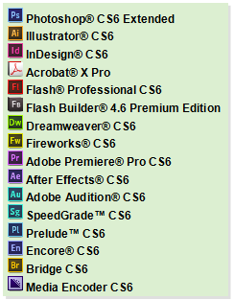Every functional area needs different types of softwares. Especially marketing, because they would need the whole of Adobe. They would need this, because Marketing manage promoting the business side of the organisation and it’s vital they need the equipment to do this. They can promote their product through various ways. They can make websites on Dreamweaver, and Photoshop can be used to edit pictures which may be necessary for posters. Fireworks can be used to make logos and CD covers which is effective. As every functional area needs the whole of Microsoft to complete their tasks. These softwares mentioned is vital for marketing to have these as they need to complete specific tasks and without these the tasks cannot be complete. This could improve the quality of the information, because it can be faster way to promote my business on the billboards. They would need anti-viruses for each computer to protect their data; same as all computers in the organisation, they would need to have antivirus on their computer. They would need to be updated as they can be new ways to protect their data

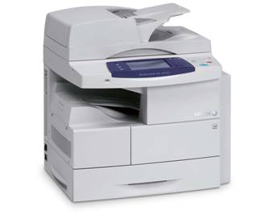Hardware in the marketing department is important. The capacity of the RAM of every computer is important. If they have a limited amount of space, they will only be allowed to produce limited amount of work. They will need a computer with a high amount of capacity so the employees can store as much data as possible. Keeping in mind that they can delete unnecessary information. They can have these printers. They can copy, scan and print for the business as this is beneficial and can improve the quality of the information by not going elsewhere to print, you can print yourself. This means it will save time. Yes, it will cost extensively, but it will save a lot of time. They would need colour printing so it would look much better and clearer to put up as a poster. Rather than black and white printing, colour printing is clear. This is expensive, but it’s better than having everything black and white. As we are dealing with promoting the business, they would need better graphics card for better graphics for the computer. First of all, they could start as a basic Intel computer, but if these cause enormous amount of issues, they could be replaced by a new processor. Remembering in mind that new processors and computers cost a lot.

Training people in this sector is vital, because knowing how to use all the adobe softwares are vital. For example Photoshop is very complex to use, professional people use Photoshop and if they have knowledge of how to use Photoshop, it will be a competitive advantage. They can attract more customers if they have interesting and appealing designs for their target audience. Also, if I have the latest technology, it will appeal and motivate my employees to work more as they find it interesting. Movies can be made and if the design aspect of the advert is superb, it can produce an appealing result. By getting more experience staff, it will produce an excellence result. The manager of the organisation can regularly test these employees. For example, set out a test for all employees to make an advert. Once they have the training, they would need motivation set by each manager for each functional area. They could try to set various ways of motivating the employees to be more efficient. This is beneficial as more work would be complete. On the other hand, motivating staff may take out hours of their working time, but it would be a benefit in the long-term.



Finance manages all the money such as;

**Finance**

* *Wages of employees*
* *Create financial accounts*
* *Pay creditors*
* *Profit*
* *Rent*
* *Income of business*
* *Outcome of business*

They manage all of the mentioned above. This links to *Marketing, and Government.*

Marketing links to finance, because if the Marketing department market their product through leafleting, they would need to contact Finance department to sort out the payment.

Government links to finance, because they need to tax all the employees’ salaries. They would need the information of how much they get yearly so the government could contact the finance department of how much the employees needs to be paid. Cost effective means if a product is made it should come in cheap. For example, if a product is made and there are two types of metal needed, but they work the same. One of them is cheap and the other is not cheap. Cost-effective is when they choose the cheaper hand for the production method to come in cheap. This comes in handy for the manufacturing and production department. If the information was not cost-effective, then they would be simply wasting the money. Having the right level of detail- This means taking the right points for what is beneficial. This links to the marketing department, because if they are advertising there business on a leaflet, they will need to have the right amount of detail. So you don’t want to give too much detail away and too little detail. The amount of information needs to be correct for the customers to understand. If the information was not the right level of detail, the customers wouldn’t either be satisfied or confused.

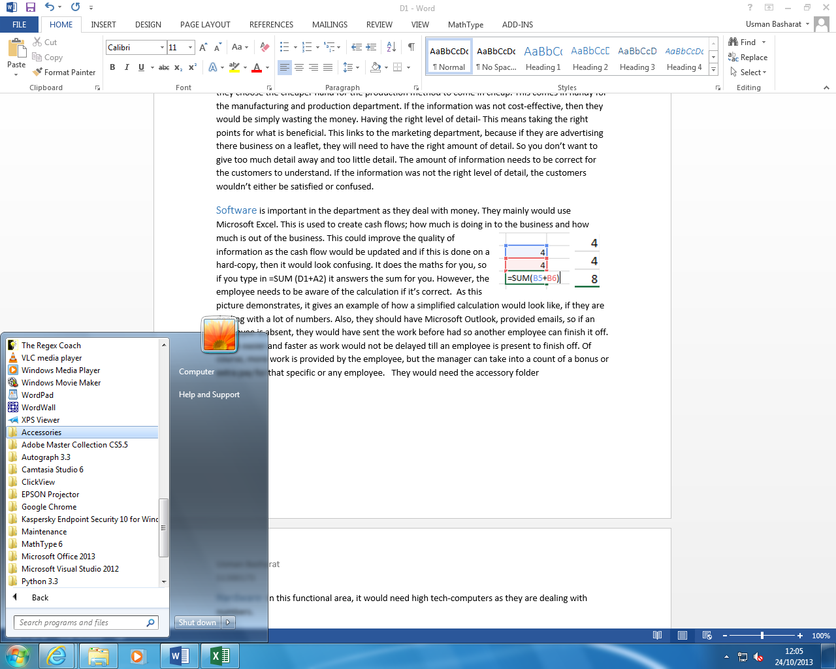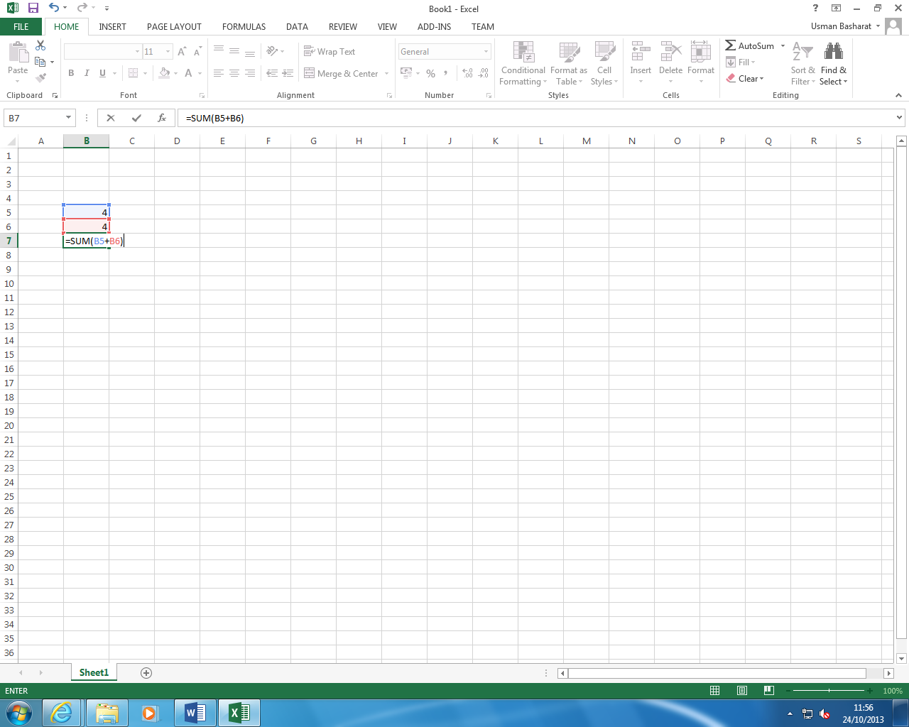Software is important in the department as they deal with money. They mainly would use Microsoft Excel. This is used to create cash flows; how much is doing in to the business and how much is out of the business. This could improve the quality of information as the cash flow would be updated and if this is done on a hard-copy, then it would look confusing. It does the maths for you, so if you type in =SUM (D1+A2) it answers the sum for you. However, the employee needs to be aware of the calculation if it’s correct. As this picture demonstrates, it gives an example of how a simplified calculation would look like, if they are dealing with a lot of numbers. Also, they should have Microsoft Outlook, provided emails, so if an employee is absent, they would have sent the work before had so another employee can finish it off. This is easier and faster as work would not be delayed till an employee is present to finish off. Of course, more work is provided by the employee, but the manager can take into a count of a bonus or extra pay for that specific or any employee. They would need the accessory folder such as; notepad, calculator, paint. Notepad can remind the employee of what work to complete. They would need anti-viruses for each computer to protect their data; same as all computers in the organisation, they would need to have antivirus on their computer. They would need to be updated as they can be new ways to protect their data

Hardware- In this functional area, it is recommended to get high tech-computers as they are dealing with numbers. However these would be expensive, but as the business gradually grows, they can get higher processor and computer. First of all, they could start as a basic Intel computer, but if these cause enormous amount of issues, they could be replaced by a new processor. Remembering in mind that new processors and computers cost a lot. This goes to every single department. If the issues cost more than a computer, I would get a new computer. The data is lost, but all departments could have a USB where they save their work. They could use that external USB to work at home, if have excessive amount of work that they can’t complete. They can save all their work on the USB and take it home and complete it there.

[](http://www.google.co.uk/url?sa=i&rct=j&q=&esrc=s&frm=1&source=images&cd=&cad=rja&docid=9lMgEbnshDrqlM&tbnid=AmS1m4agYSJRfM:&ved=0CAUQjRw&url=http://www.jeremyjacobs.com/?p=4450&ei=UQJpUtONKqyg7AbUpYEY&bvm=bv.55123115,d.ZGU&psig=AFQjCNFooKAudIHWTNR3UJieyB3_K-Ghyw&ust=1382699981252245)Training people- As all departments, people need to know how to use Microsoft Excel and the equipment for the finance. This is important because if the employees doesn’t know how to use Microsoft Excel, they wouldn’t be able to complete the work. However, it is beneficial that the employees have Excel skill as they will complete the work on time. It would need to be updated so they would need information from other functional areas to complete some work. This data would need to be efficient for the work to be complete. All employees need to be organised, because USBs can tend to be lost and if they have information completed on the USB, but don’t have on the computer. They would need to complete it again. So all employees need to ensure that to be organised.

***Summary***

All these software, hardware and training people mentioned in every functional area must cost extensively, but the beneficial side of this aspect is that it will benefit the business in the long-term. Also, it can be a competitive advantage, because if two organisations sold suits but one was better quality presented, it will gain sales. Successful employees that have been newly recruited has to have the specific skills that are set. These are important, because if they don’t have the skills set, they would need to be re-selected. All the softwares that are mentioned are vital in each functional area.